Reinforcement Learning – Assignment 2 - Bongo Board

鄧宗岳 80875505H

Department of Electrical Engineering National Taiwan Normal University Taipei, Taiwan

[yondeng@gmail.com](mailto:yondeng@gmail.com)

Jan 1, 2020; updated Jan 15, 2020

# Introduction

The problem of balancing a pole on a rolling ball is a widely used benchmark problem for testing reinforcement learning algorithms. The classic papers that introduced cart-pole problem contain mistakes in the equations that govern the dynamics of the cart-pole system. Here we provide the equations that describe the dynamics of bongo-board system.

Here, we model the humanoid robot and the bongo board as a simple linear inverted pendulum problem. We assume that the board does not slip on the roll and hence the board rotates around a point at the bottom of the circle. The roll angle θ is limited by the length of the board B l and the diameter d of the cylinder under the board. The control allows actuation at point C that the mass rotates around point C. The simplified dynamics of the system are those of a linear inverted pendulum considering the extra length d and θ. You can ignore the specifics of the dynamics for this assignment.

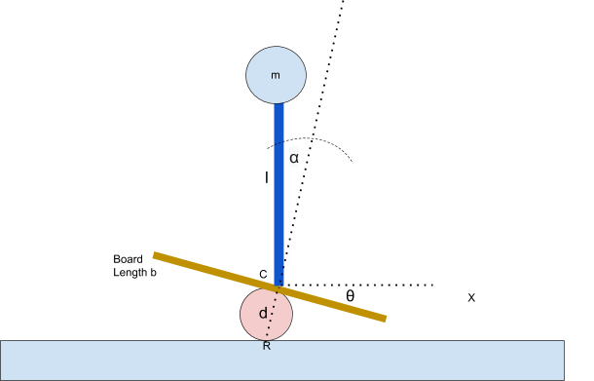

1. Simplified linear inverted pendulum model of a robot on a Bongo board

# Dynamical System

According Fig1, the mass ball have 5kg and then the pendulum pole and mass ball both influenced by gravity. But this system ignore gravity. So, Action decide plus 1 acceleration or minus 1 acceleration (Shown as Fig 2). This system via action value calculate alpha, alpha dot, theta and theta dot.

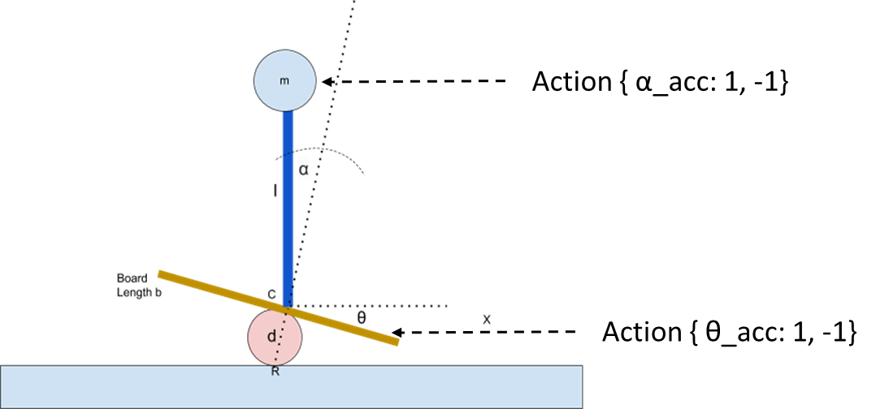

1. Push Bongo-board system

Form 1 is dynamical algorithm (acc is acceleration for alpha and theta).

|  |  |
| --- | --- |
| $α=α+t×\dot{α}$ $\dot{α}=\dot{α}+acc×t$ $β=β+t×\dot{β}$ $\dot{β}=\dot{β}+acc×t$ | (1) |

Form 2 is reward rule. In order to track center point, when the pendulum pole and board approach 0-degree reward will bigger than approach limit angle.